Moodle Quick Start Guide for Teachers

(adapted from “Getting Started for Teachers” from Moodle.org; published under GNU Public license)

Before you start

This quick start guide assumes that you have a Moodle site set up and are logged into a course with teacher privileges. For more information on installing Moodle and setting up new courses, talk to your Moodle administrators or see www.moodle.org.

To try out various Moodle features on a demo site, go to http://demo.moodle.org.

Basics

On the left side of the screen, under Administration, you will find the Settings menu to set the basic parameters for your course. These include who can come into the course, how the course is laid out, and other functions.

Most course homepages are broken into course sections (often by week or topic). Resources and activities are included for each section. The course settings also include different ways to enroll students and whether guests will be allowed access.
Tip
This icon will give you help and explanation about the various dialog boxes, features, and options in Moodle.

The screen shot on the next page shows a new course set up with topic sections in the middle column. In the right and left columns are a few of Moodle’s many blocks such as “Latest News” or “Administration.”

After you have edited the course settings, you are ready to begin adding resources and activities. Make sure that editing is turned on to do this.

Editing Your Course

The main elements of a Moodle course are resources and activities. To add or edit these, use the “Turn editing on” button on the course homepage.The same button will also turn editing off. Similarly, the “Turn student view on” button allows the teacher to see the course page as a student would see it.

To add items to a section, use the drop-down boxes for activities and resources.

When editing is turned on, a variety of editing icons appear next to all editable objects in the course. See next page for the most common icons in Moodle.
Main Moodle Course View (student)

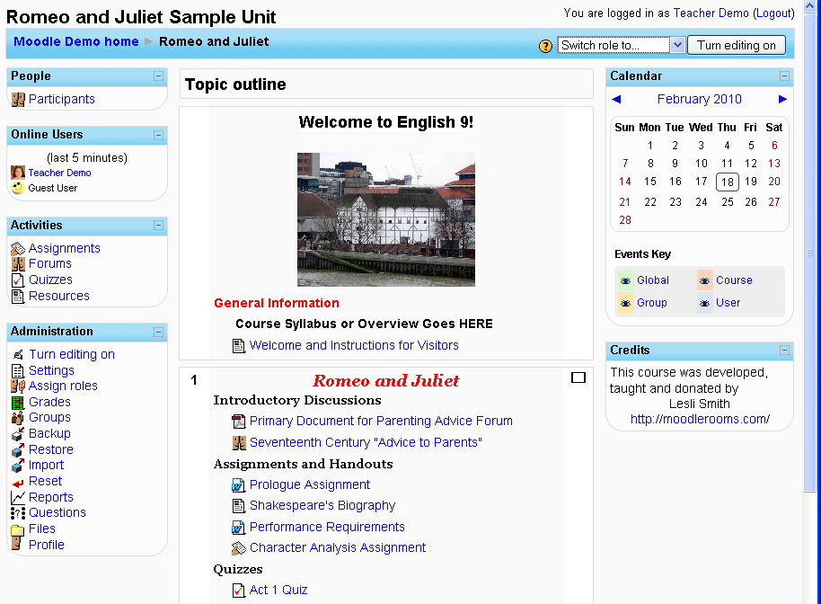
Lists of participants, online users, activities, and admin options
Blocks defined by teacher
Turn editing on or off or change view

Main view of course sections with resources and activities

Commonly used icons in Moodle
See all weeks/topics
See one week/topic
Highlight as current topic
Help

Indent right
Move up/down
Edit item
Delete
Hide item
Show item

Resources

Resources are the main units of content in a Moodle course.
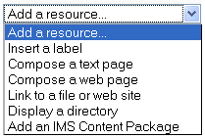
Moodle supports a range of different resource types that allow you to include almost any kind of digital content into your course. These can be added by using the “Add a resource” dropdown box when editing is turned on.

Here are the different types resources. (The most commonly used for beginners are marked with asterisks.)

Labels allow you to add text or images between activity or resource links in your course.

A Text page is a simple page written using plain text from a link in the course. Text pages aren’t pretty, but they’re a good place to put basic information or instructions.

* For more options, add a Web page. This will let you include advanced formatting, images, links, and more. Generally, this is the most flexible resource to use.
Tip
This icon lets you edit a resource or activity in your course.
* If your resource already exists in an electronic form, you can link to it as an uploaded file or external website. This is another extremely useful resource type.

You can also display the complete contents of a directory in your course files and let your students pick the file themselves.

If you have an IMS content package, this can be easily added to your course.

Activities

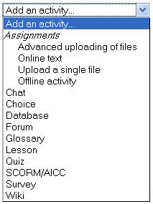
Activities are the main interactive portions of a Moodle course.

There are a number of robust interactive learning activity modules that you can add to your course with the “Add an activity” dropdown menu. If you wish, some or all of these activities can push information to your course gradebook.

Here are the main types of activities in Moodle. (The most commonly used for beginners are marked with asterisks.)

* Work can be uploaded and submitted by students and scored by teachers using Assignments. There are several assessment options, including instructor-assessment, self-assessment, and even peer-assessment.

* Communication and collaboration can happen with live Chats or asynchronous discussion Forums for conversational activities.

You can use Choices to get group feedback via a quick poll.

Glossaries of keywords can be set up by the teacher and can be configured to allow students to edit, add, or rate entries.

Lessons and SCORM activities deliver content and offer ways of individualizing your presentation based upon a student’s choices or answers to certain questions.

* Online Quizzes offer several options for automatic and manual scoring. (You can also integrate your Hot Potato quizzes by adding a Hotpot activity.)

Surveys and Databases are also very powerful additions to any course.

Adding Wikis to your courses is an excellent way to allow students to work together on a collaboratively-authored project.

If all of that isn’t enough for you then you can also add any number of additional contributed modules that are not part of the official Moodle release!

Blocks

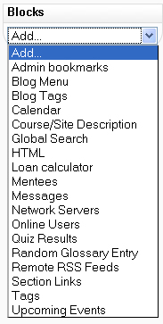
Blocks are small boxes on the right and left sides of the course homepage that show valuable information to both teachers and students.

Blocks can be configured by the teachers when editing is turned on and may be added, hidden, deleted, and moved up, down and left/right.

Blocks seen by students

A wide range of over 16 different block types can provide additional information or functionality to the learner by the teacher. Examples of blocks can be seen in the main course view screen above. “Latest News,” “Upcoming Events,” “Recent Activity,” and “Random Glossary Entry” are a few examples.

Course administration block

A teacher with editing rights will also see a course administration block on the left side of the homepage. This is an important tool for a teacher. It has sub-menus for course backup, restore, assigning roles, grades, activity logs/reports, files and the useful course settings.

A student’s course administration block typically lists only Grades and Profile options.

General advice

Use the navigation bar at the top of each page. This will help remind you where you are and prevent you from getting lost.

Subscribe yourself to all of the forums in your course so that you can keep in touch with your class activity.

Encourage all students to fill out their user profile (including photos) and read them all. For purely online courses in particular, this will help provide some context for their later writings and help you to respond in ways that are tailored to their needs.

Use the Logs link (under Administration) to get access to complete, raw logs. There you’ll see a link to a popup window that updates every sixty seconds and shows the last hour of activity. This is useful to keep open on your desktop all day so you can feel in touch with what’s going on in the course.

Make use of reports, including Reports in the Administration block and Activity Reports (next to each name in the list of all people or from any user profile page). These provide a great way to see what any particular person has been up to in the course.

Respond quickly to students. Don’t leave it for later – do it right away. Not only is it easy to become overwhelmed with the volume that can be generated, but it’s a crucial part of building and maintaining a community feel in your course.

Course design advice

Think about good instructional design when setting up your Moodle course. Start with your learning objectives, and then choose resources and activities that support them.
- Start small, and don’t feel that you have to use every feature available.

Don’t try to replicate a traditional classroom environment with Moodle. Instead, use it for what it is good for – giving students independence to control their own learning.
- Don’t feel the need to hide course sections that are not being used currently. Often students will use past or future sections for review or enrichment to differentiate and individualize their own learning.
- Look at other Moodle courses to see how teachers are using different kinds of resources and activities in new ways that you may not have thought of.

Don’t be afraid to experiment: feel free to poke around and change things. It’s hard to break anything in a Moodle course, and even if you do it’s usually easy to fix it.

Additional Resources

Moodle download and support
www.moodle.org

Moodle documentation
http://docs.moodle.org

Using Moodle (free online version)
http://docs.moodle.org/en/Using_Moodle_book

