Shotcut Quick Start Guide

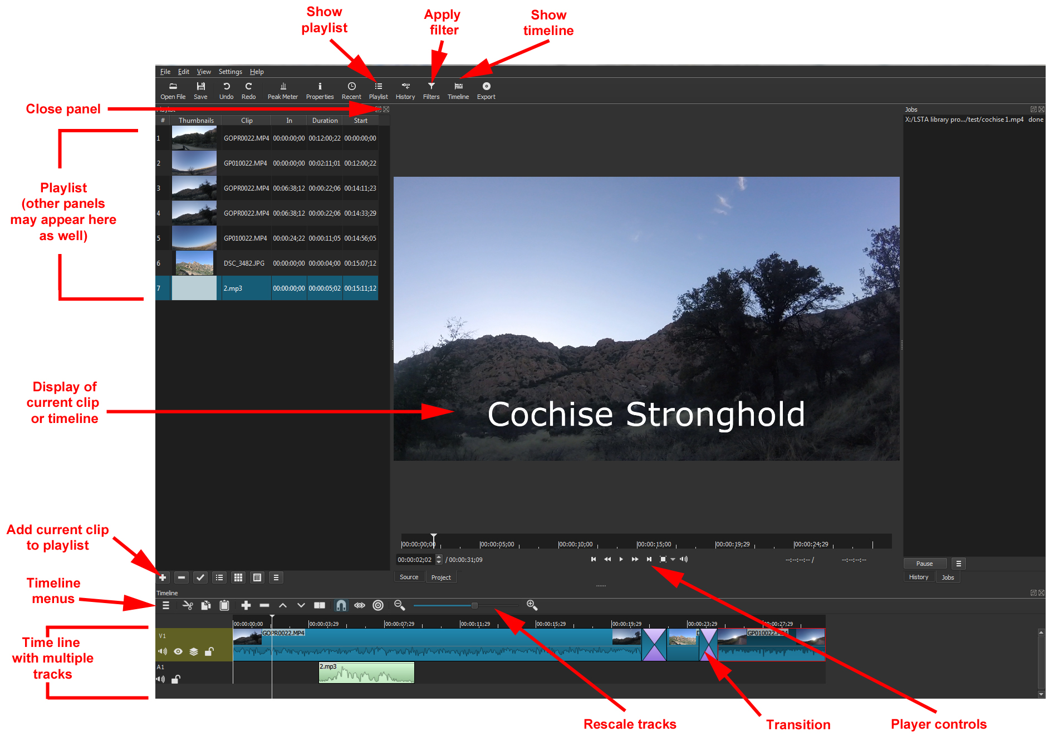
ShotCut (www.shotcut.org) is a free, open source tool that runs on Windows, Mac, and Linux. It can be used as a media player or a video editing tool. Tutorials are available at www.shotcut.org/tutorials/

Adding video clips, audio or images

You may begin my assembling all of your media items into a playlist. This will serve as a “bin” from which you can create your timeline. To do this:

- Open the Playlist panel by clicking Playlist 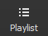 on the top menu. The Playlist panel will appear on the left side.
- Drag and drop media elements from their folder into the Playlist panel.
OR
- Use Open File on the top menu to open a file in the player. Set the in and out points of the clip in the player if you like and then use the plus button at the bottom of the playlist panel to add it to the playlist.

Alternatively, you can drag and drop media elements directly into your timeline.

Using the Timeline

- Open the Timeline panel by clicking Timeline 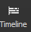 on the top menu. The Timeline panel will appear at the bottom of your screen.
- Drag and drop a media element from a folder or from your Playlist to add it to the Timeline.
- To create a new audio or video track, use the Timeline menu button and Add Audio Track or Add Video Track.
- Use the other buttons to append, delete, cut, copy or paste clips. You can also right-click or drag clips to move them.
- In the event of multiple tracks with visuals, the top-most track is what will appear in the final output.

Adding Transitions

- To add a transition such as a fade, you must have two media clips immediately adjacent to one other on the same track of the timeline.
- Drag one media element to slightly overlap the other to add a transition.
- The transition can be resized by dragging the handles.
- Select the transition and click Properties in the top menu to display and edit its properties (both video and audio).

Adding Captions or Title Screens

Text or captions can be added to a video by using a filter. (Other filters are available for things like fading in or out audio or video, normalizing audio, stabilizing video, adjusting brightness or contrast, cropping, etc.)

- First select the clip or track you wish to apply the filter to.
- Click Filters in the top menu.
- Click + in the Filters panel.
- Select the filter you wish to apply. (Note: shows your favorite filters. shows all video filters. shows all audio filters.)
- Adjust settings as needed.

Notes: Fancier title screens are best added as graphics. Closed captions can be added with YouTube.

Recording Narration

- You can record directly into Shotcut by going to the File menu and selecting Open Other.
- Under Devices, choose Direct Show and your microphone under Audio Devices. To begin the recording, choose the WAV preset and Capture File.
- Record your audio, and click Stop Capture when done.
- The file you recorded will be in your main viewer and can be added to your Playlist or Timeline.
Alternatively, you can record in Audacity, export to a WAV or MP3 file, and import into Shotcut.

Saving your Project

- Make sure to save your project as you work by using the Save button in the top menu.
- Saving the project will create an MLT XML (.mlt) file. This can be opened and edited in Shotcut but cannot be viewed as a video by people who do not have the Shotcut program.

Exporting Your Final Video

- Use the Export button on the top menu to render your video for viewing.
- Complete all your edits first.
- Then click Export.
- Set the options you like and then click Export File. For video to be uploaded a web site, H.264 Main Profile is a good option.
Note that rendering a final video can take some time, depending on the length and complexity of your project.

Extras:

- Panels, such as the Playlist or Filters, can be closed by clicking the X in the upper right corner.
- If you’re not sure what a button does, mouse over it for a clue.
- The various panels and screen areas in Shotcut can be resized or detached to optimize viewing and use.
- More help available at www.shotcut.org

