Quick Start Guide to Creating Ebooks with Calibre

This is a quick, easy way to make ebooks from a Word document. Before beginning, download and install Calibre, a free, open source ebook tool from http://calibre-ebook.com.

- Create your ebook content in Word (or LibreOffice…or even in Google Docs, then export to a Word doc afterward), including images, etc.
- Make sure your images are your own or open licensed for sharing, and cite your sources!
- From Word, export the document to HTML (filtered) by doing Save As… with a Save as type of “Web Page, Filtered.”
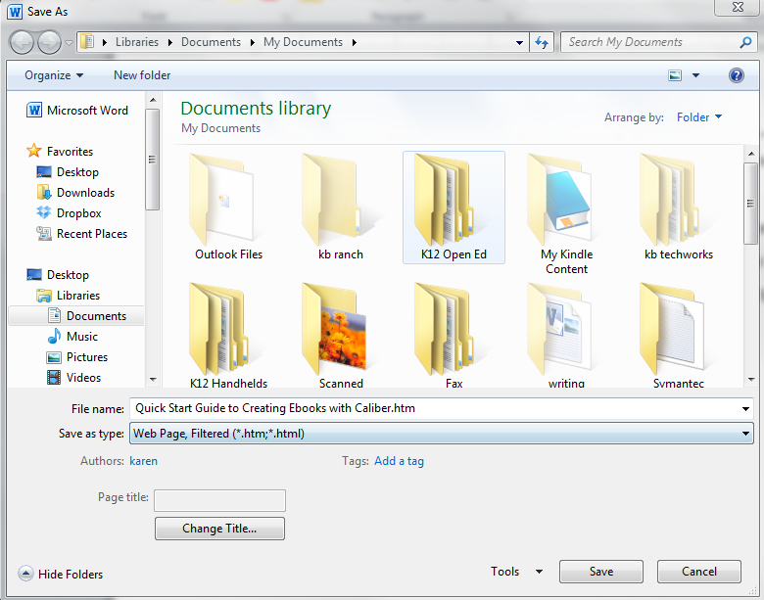

- Open Calibre, click Add Books from the toolbar, and add the HTML document you saved above.
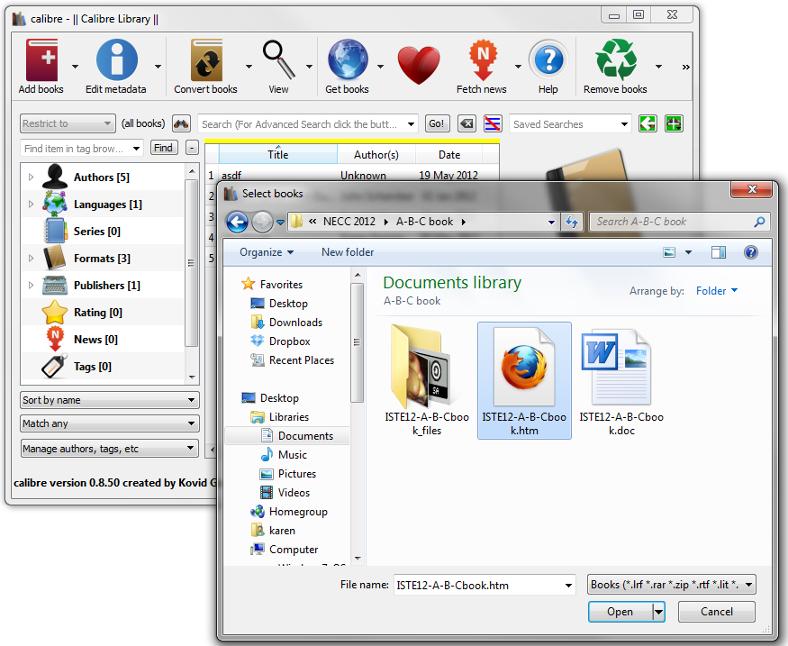

- Your book will then appear in the list in the main part of the screen. Highlight it and click Edit metadata from the toolbar to add a title, author, cover, etc. Click OK when you are done.
- When you are ready to make your ebook, highlight your title and select Convert books.
  - You will need to select an output format. EPUB and MOBI (Kindle) are two of the most popular formats. Select a format, and click OK.
- Your final ebooks will be in a folder called Calibre Library in your documents folder. You can also select your ebook in Calibre and click “Path: Click to open” to navigate directly to that folder.

